**Guidelines for PhD students**

The Ph.D program includes courses equally divided into three thematic areas identified as Molecular Biotechnologies, Industrial Biotechnologies, and Environmental Sciences. The educational offer is structured into courses, which may be further divided into modules that can also be taken individually. The teaching staff is a mix, including both professors from the University of Verona and external experts recognized in the various subjects. Given the multidisciplinary nature of the Ph.D program in Molecular, Industrial, and Environmental Biotechnologies, and considering the different academic backgrounds of the Ph.D students, some courses include an introductory module aimed at providing the advanced knowledge necessary to follow the subsequent modules. These introductory modules can be taken or not, depending on the student's prior knowledge of the topic, and they still grant academic credits.

The credits (CFU) for research activities are obtained through work on the research project, participation in conferences and workshops as a speaker or attendee, tutoring activities, research stays abroad, publications, etc. The activities carried out must be listed in the doctoral student’s annual report according to the scheme indicated in the following table:

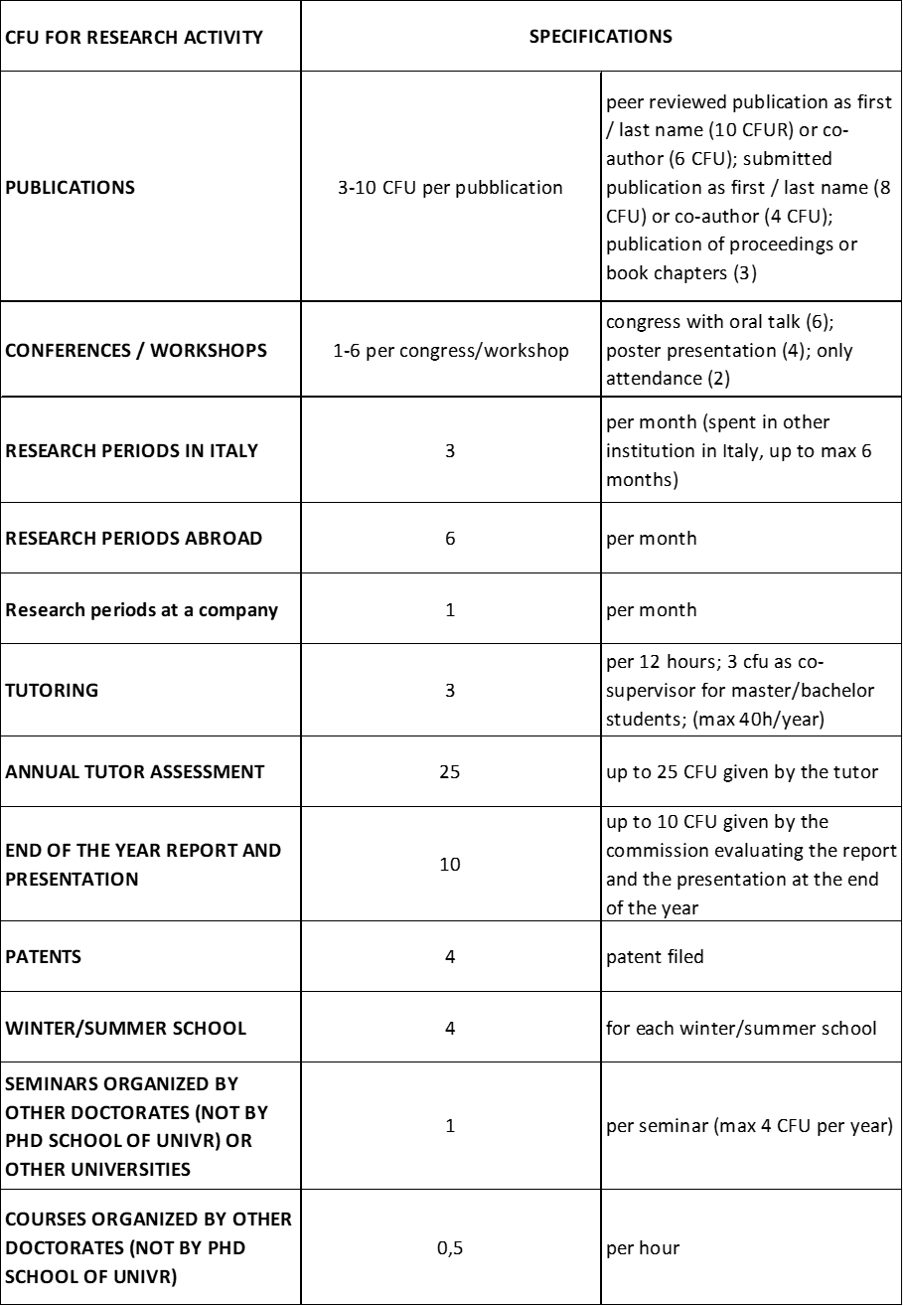

The composition of the research credits (CFU) is (self) certified by the PhD student by filling out, at the end of each year, the previously provided table, and sending it to the coordinator and the tutor. In general, a PhD student admitted to the final defense of their doctoral thesis should have submitted at least one paper as the main author in a SCOPUS-indexed scientific journal and have participated in at least one national or international conference.

Stays abroad are highly recommended if they are part of a suitable context for promoting the development of the doctoral project and entail the allocation of 2 CFU of teaching per month, of which 1 CFU counts towards the PhD course and 1 CFU towards the PhD School. Additionally, 6 CFU of research are awarded per month.