PhD School in LIFE AND HEALTH SCIENCE and PhD Program in INFLAMMATION, IMMUNITY AND CANCER present
Prof. Michele Diana
M.D., Ph.D
Professor of Surgery University “Gabriele D’Annunzio”
Chieti-Pescara, Italy
Director of the Research Unit IHU-Strasbourg, Institute of Image-Guided Surgery, Strasbourg, France
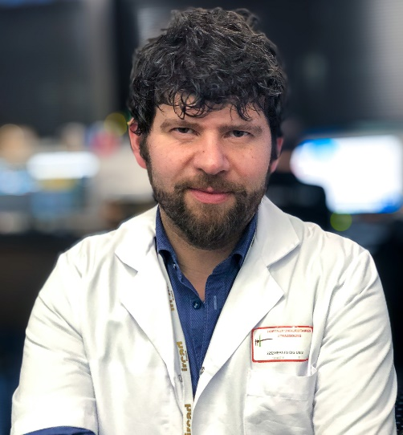

“La chirurgia cibernetica: inventando il futuro”

Wednesday, March 06, 2019, 15pm
Aula H, Lente Didattica
Policlinico “G.B. Rossi”

